Disinfection By-Product Formation Potential and DOM Characteristics of Kelani River in the Wet-Season.
Authors
Ashen Randika^{1,}**, Zhineng Hao^{1,}*, Yuansong Wei^{2,3,4,*}, Yawei Wang⁴, Hui Zhong⁴, Madhubhashini Makehelwala⁵, Sujithra K. Weragoda⁶, Rohan Weerasooriya⁷
ashen_st@rcees.ac.cn** , znhao@rcees.ac.cn*, yswei@rcees.ac.cn

¹State Key Laboratory of Environmental Chemistry and Toxicology, Research Center for Eco-Environmental Sciences, Chinese Academy of Sciences, Beijing, 100085 China
²State Key Laboratory of Regional Environment and Sustainability, Research
Center for Eco-Environmental Sciences, Chinese Academy of Sciences, Beijing
100085, China
³Laboratory of Water Pollution Control Technology, Research Center for Eco-Environmental Sciences, Chinese Academy of Sciences, Beijing 100085, China
⁴University of Chinese Academy of Sciences, Beijing 100049, China
⁵China-Sri Lanka Joint Research and Demonstration Center for Water Technology,
E.O.E Pereira Mawatha, Meewathura, Peradeniya, Sri Lanka
⁶National Water Supply and Drainage Board, Sri Lanka
⁷National Institute of Fundamental Studies, Hanthana Road, Kandy 20000, Sri Lanka

Keywords: Disinfection by-products formation potential; dissolved organic matter; wet season; downstream
Abstract
The downstream Kelani River in Sri Lanka is highly vulnerable to monsoon-driven changes in water quality, leading to elevated dissolved organic matter (DOM) loading and enhanced formation of disinfection by-products (DBPs) during chlorination. This study quantified wet-season DBP formation potential (DBPFP) and characterized DOM at both bulk and molecular scales. Twenty-two downstream samples were analyzed for THMFP, HAAFP, DOC, SUVA₂₅₄, and fluorescence indices, while four representative samples underwent Fourier transform ion cyclotron resonance mass spectrometry (FT-ICR-MS). DOC concentrations ranged from 14.00–21.01 mg/L with a mean of 16.21 ± 1.81 mg/L, and all DBPFP values were normalized to DOC. THMFP ranged from 87.9–176.1 µg mg C⁻¹, and HAAFP from 18.4–24.8 µg mg C⁻¹, reflecting consistently high precursor reactivity. DOM exhibited low aromaticity (SUVA₂₅₄ = 0.13–0.87 L mg⁻¹ m⁻¹) and strong microbial signatures. FT-ICR-MS results showed DOM dominated by CHO formulas (75–82%), with moderate contributions from CHNO (9–11%) and CHOS (7–10%) species. Intensity-weighted indices (H/C_w = 1.21–1.23; O/C_w = 0.45–0.46; NOSC_w = −0.23 to −0.28) indicated unsaturated, low-aromatic, microbially influenced DOM highly reactive toward chlorination. The combined dataset demonstrates that microbially derived, low-aromatic DOM is the primary driver of elevated wet-season DBPFP in the downstream Kelani River.
Introduction
Disinfection by-products (DBPs) form when disinfectants such as chlorine react with dissolved organic matter (DOM) during drinking water treatment. Their formation depends not only on DOM chemical structure but also on its bulk concentration, typically measured as dissolved organic carbon (DOC). In monsoon-influenced tropical rivers, storm-driven hydrological pulses mobilize large quantities of organic carbon from catchments, leading to sharp increases in DOC and substantial shifts in DOM composition(Zhou et al., 2019). These seasonal changes strongly influence DBP precursor availability and reactivity, particularly in downstream regions that receive cumulative inputs from urban runoff, storm drains, and wastewater discharges. The Kelani River as the main drinking water source supplying about 80% of water for the Colombo Metropolitan Region is highly vulnerable to monsoon-driven fluctuations in both DOC levels and DOM quality(He et al., 2022; Zhang et al., 2023). Downstream segments receive the highest pollutant loads and exhibit the greatest temporal variability in DOC, making them critical zones for DBP formation risk assessment. Therefore, the "Nationally Determined Contribution Implementation Plan (2021-2030)" issued by Sri Lanka lists the Kelani River as one of the 15 rivers for priority implementation of integrated river basin management. However, limited by the level of economic and social development, Sri Lanka lacks the ability to detect, identify, reduce and control dissolved organic matter (DOM) and DBPs in water plants(Surasinghe et al., 2020). For example, Sri Lanka's drinking water standards ( SLS 614-2013 ) do not have disinfection by-product indicators, it refers to the World Health Organization's "Guidelines for Drinking Water Quality" (4th edition) and the United States "National Drinking Water Quality Standards" (EPA-816-F-09-004). In addition, Sri Lanka lacks a special drinking water source protection policy and urgently needs scientific and technological support.
While bulk optical indicators such as SUVA₂₅₄, FI, BIX, and HIX provide insights into aromaticity, microbial contributions and humification, they cannot reveal the detailed molecular-level characteristics of DOM responsible for DBP formation. Fourier transform ion cyclotron resonance mass spectrometry (FT-ICR-MS) provides ultrahigh-resolution molecular characterization capable of identifying thousands of DOM formulas and resolving elemental classes (CHO, CHNO, CHOS, CHNOS). Combined with DOC-normalized DBPFP measurements, FT-ICR-MS enables a mechanistic understanding of how specific molecular features such as saturation level, heteroatom content, and oxidation state influence chlorination reactivity.
This study thus integrates DOC measurements, bulk optical characterization, DBP formation potential assays, and FT-ICR-MS molecular analysis to: (1) quantify wet-season DOC variability and DBP precursor loads; (2) characterize DOM structural features at both chemical and molecular scales; (3) determine how DOM composition and oxidation state explain DBP formation in the downstream Kelani River, and provide support Sri Lanka to achieve the UN SDG 6 (Clean water and Sanitation).
Methodology
Twenty-two downstream water samples were collected during the 2024 wet monsoon from locations influenced by urban runoff, industrial effluents, and stormwater drainage. Dissolved organic carbon (DOC) was measured using a TOC analyzer, and optical properties of DOM—including SUVA₂₅₄, fluorescence index (FI), biological index (BIX), and humification index (HIX)—were determined using UV–Vis spectroscopy and three dimension excitation–emission matrix (3D EEM) fluorescence. Disinfection by-product formation potential (DBPFP) assays for trihalomethanes (THMFP), haloacetic acids (HAAFP), haloacetonitriles (HANFP), and chloral hydrate (CHD) were performed following Standard Methods by chlorinating samples at controlled chlorine doses, incubating them for seven days, quenching residual chlorine, and analyzing DBPs via gas chromatography with electron-capture detection; all DBPFP values were normalized to DOC (µg DBP per mg C) to evaluate precursor reactivity independently of carbon concentration. To resolve DOM composition at the molecular scale, four representative samples covering low, medium, and high DBPFP levels were subjected to solid-phase extraction and analyzed using Fourier transform ion cyclotron resonance mass spectrometry (FT-ICR-MS). Assigned formulas were filtered by mass accuracy and isotopic patterns, grouped into elemental classes (CHO, CHNO, CHOS, CHNOS), and used to calculate intensity-weighted molecular indices including H/C, O/C, DBE/C, AI_mod, and NOSC to characterize DOM saturation, aromaticity, and oxidation state(Peng et al., 2020).
Results
DOC concentrations in the downstream Kelani River during the wet season ranged from 14.00 to 21.01 mg/L (mean 16.21 ± 1.81 mg/L), while SUVA₂₅₄ values were low (0.13–0.87 L mg⁻¹ m⁻¹), indicating low-aromatic DOM as shown in Table 1. Despite moderate DOC levels, DBP formation potential was high, with THMFP ranging from 87.9 to 176.1 µg mg C⁻¹ and HAAFP from 18.4 to 24.8 µg mg C⁻¹, whereas HANFP and chloral hydrate showed episodic increases during storm-related inputs. FT-ICR-MS analysis of four representative samples showed that DOM was dominated by CHO formulas (79.2%), with smaller fractions of CHNO (9.8%), CHOS (8.7%), and CHNOS (3.5%), and exhibited low-aromatic, unsaturated characteristics (H/C₍w₎ = 1.22, O/C₍w₎ = 0.45, DBE/C₍w₎ = 0.445, AI_mod₍w₎ = 0.277, NOSC₍w₎ = –0.25) (Table 2). These combined results indicate that DOM in the wet-season is largely microbially influenced and chemically reactive, contributing to elevated DBP formation despite low aromaticity (Figure 1).
Table 1: DOC concentration in the downstream of Kelani River
Parameter | Range | Mean ± SD
DOC (mg/L) | 14.00–21.01 | 16.21 ± 1.81
SUVA₂₅₄ (L mg⁻¹ m⁻¹) | 0.13–0.87 | 0.33 ± 0.19

Table 2: FT-ICR-MS DOM Composition
CHO (%) | CHNO (%) | CHOS (%) | CHNOS (%) | H/C₍w₎ | O/C₍w₎ | DBE/C₍w₎ | AI_mod₍w₎ | NOSC₍w₎
79.2 | 9.8 | 8.7 | 3.5 | 1.22 | 0.45 | 0.445 | 0.277 | –0.25

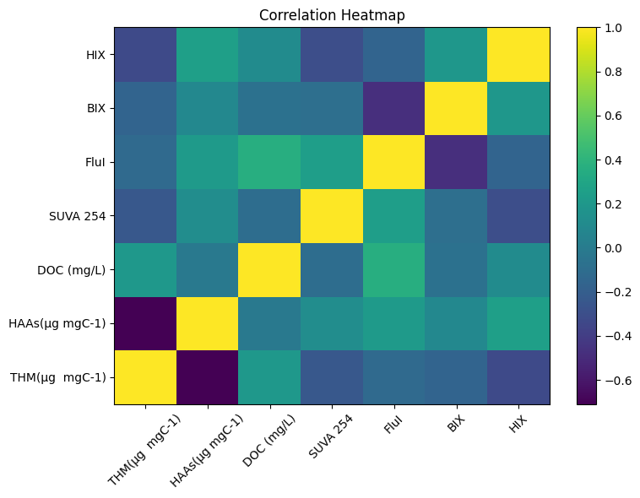

Figure 1: Correlation heatmap of DBPFP and DOM in the downstream of Kelani River.

Conclusions
The DOM of the downstream Kelani River in the wet-season is dominated by microbially derived, low-aromatic, unsaturated organic matter that exhibits strong reactivity toward chlorine, as evidenced by high THMFP values. Moderate DOC levels (16.21 ± 1.81 mg/L) and low SUVA₂₅₄ contrast sharply with the molecular signatures revealed by the FT-ICR-MS, which show abundant unsaturated CHO and CHNO compounds with reduced carbon (NOSC≈−0.25). Together, these results demonstrate that DOM composition rather than concentration or aromaticity is the primary determinant of DBP precursor reactivity. The findings emphasize the need for improved watershed controls and optimized treatment operations during monsoon periods to reduce DBP risks in downstream drinking-water intakes.

References:
He, J., Wu, X., Zhi, G., Yang, Y., Wu, L., Zhang, Y., Zheng, B., Qadeer, A., Zheng, J., Deng, W., Zhou, H., & Shao, Z. (2022). Fluorescence characteristics of DOM and its influence on water quality of rivers and lakes in the Dianchi Lake basin. Ecological Indicators, 142. https://doi.org/10.1016/j.ecolind.2022.109088
Peng, N., Wang, K., Tu, N., Liu, Y., & Li, Z. (2020). Fluorescence regional integration combined with parallel factor analysis to quantify fluorescencent spectra for dissolved organic matter released from manure biochars. RSC Advances, 10(52), 31502–31510. https://doi.org/10.1039/d0ra02706e
Surasinghe, T., Kariyawasam, R., Sudasinghe, H., & Karunarathna, S. (2020). Challenges in biodiversity conservation in a highly modified tropical river basin in Sri Lanka. Water (Switzerland), 12(1). https://doi.org/10.3390/w12010026
Zhang, X., Nie, L., Gao, H., Yu, H., & Liu, D. (2023). Applying second derivative synchronous fluorescence spectroscopy combined with Gaussian band fitting to trace variations of DOM fractions along an urban river. Ecological Indicators, 146. https://doi.org/10.1016/j.ecolind.2023.109872
Zhou, X., Zheng, L., Chen, S., Du, H., Gakoko Raphael, B. M., Song, Q., Wu, F., Chen, J., Lin, H., & Hong, H. (2019). Factors influencing DBPs occurrence in tap water of Jinhua Region in Zhejiang Province, China. Ecotoxicology and Environmental Safety, 171, 813–822. https://doi.org/10.1016/j.ecoenv.2018.12.106

