Occurrence, Proliferation Risk and Influencing Factors of Opportunistic Premise Plumbing Pathogens in Full-Stage Water Treatment Processes
Qing Lu¹, Weiying Li^{2,*}

(¹ College of Environmental Science and Engineering, Tongji University, Shanghai, 200092, P. R. China,; ² College of Environmental Science and Engineering, Shanghai Institute of Pollution Control and Ecological Security, State Key Laboratory of Pollution Control and Resource Reuse, Tongji University, Shanghai 200092, China)
Presenting Author: Qing Lu
Keywords: opportunistic premise plumbing pathogens (OPPPs); water treatment plants; risk assessment

Introduction
Opportunistic Premise Plumbing Pathogens (OPPPs) are prevalent, widely distributed biosafety hazards in urban water supplies, including Mycobacterium spp., Legionella spp., and Pseudomonas aeruginosa. These opportunistic pathogens naturally exist in water, proliferate in favorable environments, and are highly infectious to immunocompromised groups. As a key transmission route for opportunistic pathogens, OPPP control and monitoring in water supplies are critical for safety. Conventional water treatment effectively removes most microorganisms but has limited OPPP removal efficiency. Currently, systematic research on OPPP occurrence/distribution across treatment stages is lacking, and related biosafety measures urgently need improvement.

Materials and Methods
In this study, we conducted sampling at four operational water treatment plants, covering five key treatment stages: raw water inlet, coagulation-sedimentation tank effluent, sand filter effluent, carbon filter effluent, and finished water. The sampling period spanned four consecutive quarters (encompassing all seasons), with samples collected quarterly, yielding multiple water samples (sample size n=36 per stage). In this study, on-site rapid detection and laboratory detection were used to detect physicochemical indicators, qPCR and high-throughput sequencing to analyze microbial indicators.

Results and Discussion
Typical OPPPs were detected across all four water treatment plants and all treatment stages, with concentrations showing phased fluctuations (rather than monotonic decline) and peaking in the BAC process and autumn coagulation-sedimentation stage; OPPP levels were generally higher in spring/summer than autumn/winter. Turbidity, free chlorine, metals (Fe/Mn/Zn/Cu), and AOC exhibited distinct correlations with OPPPs and specific bacteria (e.g., Pseudomonas aeruginosa had strong chlorine resistance, Legionella was most sensitive).
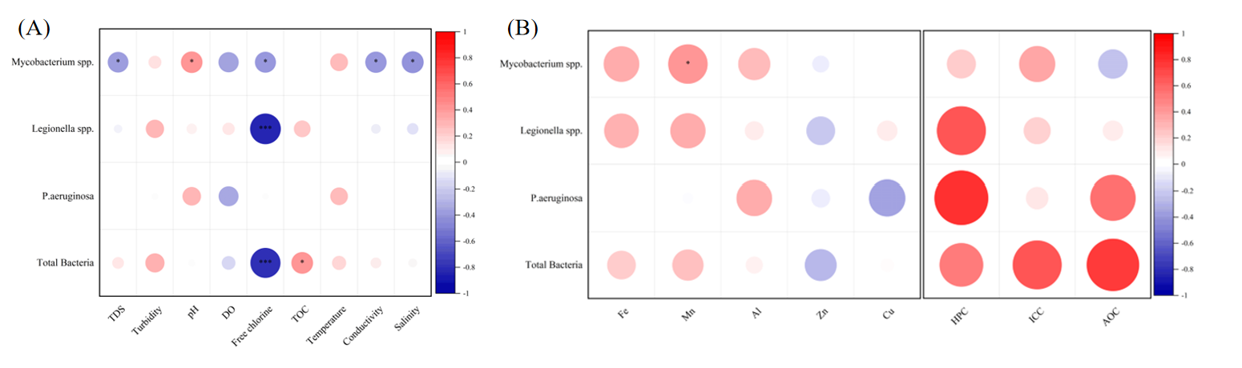
Figure 1. Effects and correlations of water quality parameters on OPPPs. (A) The correlation between conventional physicochemical indicators and OPPPs in water treatment plants. (B) The correlation between metal content and microbial indicators in water treatment plants and OPPPs.
Regarding the bacterial community structure of water treatment plants, Hydrogenophaga dominated the bacterial community; Pseudomonas rebounded post-disinfection, while Chryseobacterium surged in finished water, with community stability declining then rising after disinfection. Firmicutes gut probiotics and Pseudomonas inhibited OPPPs via metabolites and niche competition, whereas synergistic bacteria (e.g., hgcI clade, Mycobacterium) promoted OPPP proliferation, jointly driving its evolution throughout treatment.
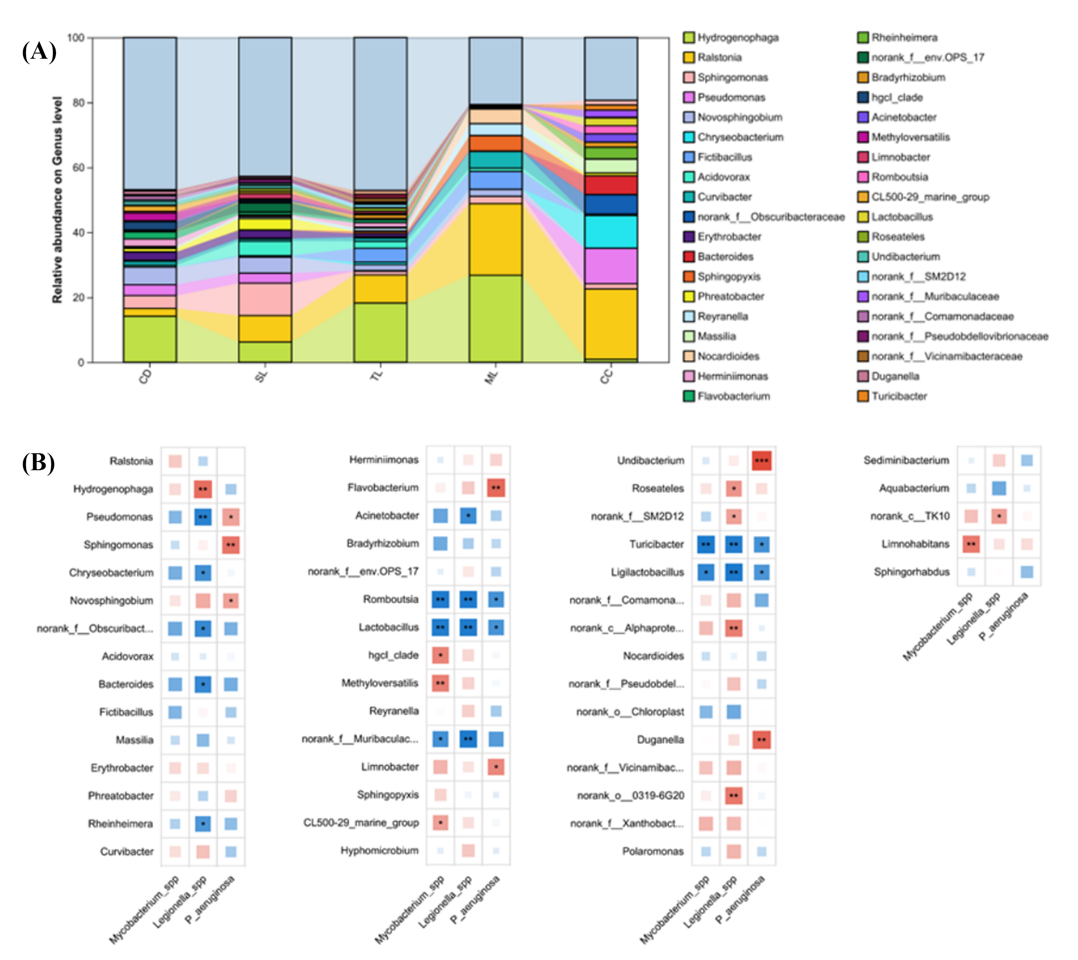
Figure 2. (A) The correlation between the dominant bacterial genera in the bacterial community and OPPPs in water treatment plants. Bacterial community structure in water treatment plants significantly regulates OPPP distribution and proliferation, featuring two core interactions: inhibitory and synergistic. (B) The hierarchical bacterial community structure in the water treatment plants. (CD: Coagulation-Sedimentation Tank, SL: Sand Filtration Tank, TL: Biological Activated Carbon Filter, ML: Membrane Filtration Component, CC: Finished Water)

Conclusions
Clarifying OPPP distribution and proliferation mechanisms, this work identifies non-monotonic OPPP concentration changes during treatment and pinpoints BAC and autumn coagulation-sedimentation as key proliferation hotspots. Seasons (higher concentrations in spring-summer), water quality parameters, and bacterial interactions regulate OPPPs. OPPPs show variable chlorination sensitivity, while Bacillota probiotics (e.g., Lactobacillus) inhibit them via metabolites and niche competition, providing new theoretical support for water microbial regulation. Targeted process optimizations are proposed: control ozone dosage, optimize activated carbon regeneration, and monitor winter temperatures for BAC; adopt season/pathogen-specific disinfection, supporting water supply safety upgrades.

References
LeChevallier, M.W., Prosser, T., Stevens, M. 2024. Opportunistic Pathogens in Drinking Water Distribution Systems—A Review. Microorganisms. 12, 916.
Zhao, B., Liu, R., Li, Y., Xu, H., Li, X., Gu, J., Zhang, X., Wang, Y. and Wang, Y. 2024. Changes of putative pathogenic species within the water bacterial community in large-scale drinking water treatment and distribution systems. Water Res. 249, 120947.
Clements, E., Crank, K., Nerenberg, R., Atkinson, A., Gerrity, D. and Hannoun, D. 2024. Quantitative Microbial Risk Assessment Framework Incorporating Water Ages with Legionella pneumophila Growth Rates. Environ. Sci. Technol. 58(15).

