Kinetic study and DFT calculation on the tetracycline abatement by peracetic acid
Xiao-Dan Zhao*, Dan-Ying Xing

(College of Chemical Engineering, Huaqiao University, Xiamen 361021, China)
Presenting Author: Xiaodan-Zhao

Keywords: Peracetic acid; Tetracycline; Kinetics; Rate constants

Introduction
Tetracycline antibiotics (TCs) are a class of broad-spectrum antibiotics produced by actinomycetes, the frequent detection of which in medical wastewater may lead to bacterial resistance with potential harm to ecosystems (Duong et al.). Therefore, it is of significance to study the effective technologies for rapid TC abatement. Peracetic acid (PAA) is a typical oxidant and widely used in wastewater treatment, disinfection, medical, chemical and paper industries(Wang et al.). Regarding that PAA is an electrophilic reagent and TC contains several electron-rich fractions, TC is expected to exhibit considerable reactivity toward PAA. A previous study has demonstrated the reactivity between PAA and TC, yet the species-specific reactions for the reaction of PAA and TC are not clear, and the electron-donating and electron-accepting properties of the different species of TC and PAA needs to be elucidated.
Therefore, the objectives of this work are: (i) To evaluate the efficacy of oxidative abatement of TC by PAA for different pH conditions and (ii) to construct the kinetic model and calculate the species-specific reaction rate constants for the reaction between PAA with TC.

Materials and Methods
Tetracycline (TC, 95.0%) was purchased from Sigma-Aldrich Co., China. H₂O₂ (30%) and CH₃C(O)OH (purity >99.0%), H₂SO₄ were supplied by Sinopharm Chemical Reagent Co., Ltd. (Shanghai, China). Peracetic acid (PAA) was prepared by the reaction of H₂O₂ and CH₃C(O)OH in the presence of H₂SO₄.

Results and Discussion
Figure 1(a) presents TC abatement as a function of time by PAA under different pH conditions. TC abatement is monitored under different pH conditions via controlling the ratio of PAA:TC. The apparent second-order rate constants (k_{2, app}) are determined in the pH range of 3.0−11.0 (Figure 1(b)). As can be seen, TC abatement under alkaline conditions is more efficient than under acidic conditions. This is mainly due to the increased deprotonation of TC under alkaline conditions, where the electron density of deprotonated TC is higher than that of protonated TC, thus facilitating the attack of PAA [2]. However, as the pH continues to increase, the proportion of deprotonated PAA is the dominant species, leading to the decrease in its ability to TC oxidation.
Figure 2 displays the value of the species-specific rate is obtained by least squares regression of the experimental k_{2, app} via the user-defined nonlinear regression equation in the Origin software based on the speciation of PAA and TC. The experimental k_{2, app} and modeled k_{2, app} can be well fitted and the species-specific rate constants can be correspondingly calculated, as shown in Fig. 2d. In the fitted data, the reaction rate constant between PAA⁻ and TTC⁺ is 0. At the same time, the mole fraction of PAA⁻ and TTC⁺ is extremely low (Fig. 2c), so the reaction between PAA⁻ and TTC⁺ can be negligible in the overall reaction. The reaction of protonated PAAH to each species of TC is significantly higher than that of the deprotonated PAA⁻. Especially, the species-specific reaction of PAAH with TTC²⁻ is significantly higher than that of the other species, which mainly contributes to the reaction between PAA and TC. For different TC species, the reactivity of PAA follows an order of TTC²⁻ > TTC⁻ > TTC. This is mainly because the higher deprotonation of TC means the higher electron density of ring structure. Interestingly, the reactivity between PAA⁻ and each species of TC is opposite to PAAH. This is mainly due to the electrostatic repulsion between the negative charge of deprotonated PAA⁻ and that of deprotonated TC, which results in a decrease in their reactivity.
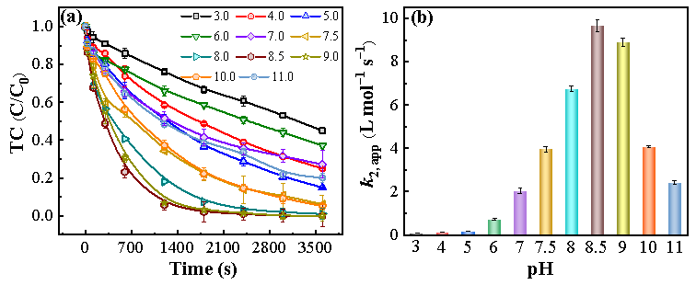
Figure 1 (a) TC oxidation abatement by PAA under different pH. (b) The k_{2,app} of TC abatement under different pH. Experimental conditions: [PAA] = 200-3000 µmol/L, [TC] = 20 µmol/L, pH 3.0-11.0.
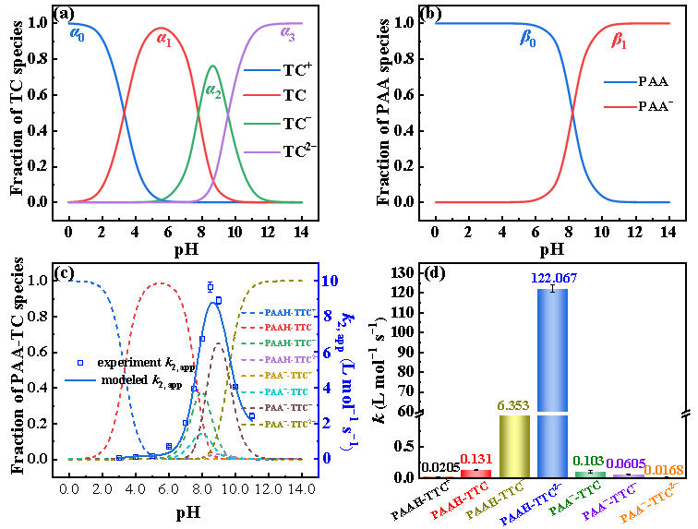
Figure 2 (a) TC speciation (b) PAA speciation. (c) Effect of pH on the PAA-TC species (βj × αi) and kinetic modeling for the k2, app of TC with PAA. (d) Species-specific reaction rate constants for PAA with TC. Experimental conditions: [PAA] = 200-3000 µmol/L, [TC] = 20 µmol/L, pH 3.0-11.0.

Conclusions
In this work, the kinetics for the reaction between TC and PAA is explored, which can be significant for the application of PAA in the treatment of TC-containing wastewater.

References
Loan Thi Kim Duong, Thuy Thi Thanh Nguyen, Thuan Van Tran et al. 2024. Combined pollution of tetracyclines and microplastics in the aquatic environment: Insights into the occurrence, interaction mechanisms and effects, Environ. Res. 263, 120223.
Zhenxin Wang, Yifan Yin, Jiaqi Yang, et al, 2026. Electron transfer-driven polymerization of phenolics via CuO-catalyzed peracetic acid for sustainable wastewater remediation, J. Hazard. Mater. 501,140680.

