The role of biochar in algal source water treatment: Algal cells integrity and NDMA formation potential^{[1]}
Wen Qin¹，Jingru Yang¹，Changyang Zhang¹，Yang Song^{1,*}
(1 School of Civil and Transportation Engineering, Guangdong University of Technology, No. 100, West Waihuan Road, Guangzhou Higher Education Mega Center, Guangzhou, Guangdong, China)
Presentation Author: Wen Qin (qinwen@gdut.edu.cn)
Keywords: nitrogen-containing disinfection by-products; disinfection; NDMA; algae; biochar
Introduction
Organic matter released by algae in source water leads to the risk of disinfection by-product formation during disinfection^{[2]}, especially organic nitrogen in algal cells causes the formation of nitrogen-containing disinfection by-products with higher toxicity^{[3]}. N-nitrosodimethylamine (NDMA) is a typical nitrogen-containing disinfection by-product, with its strong carcinogenicity and potential threat to drinking water safety^{[4]}. This study was conducted to investigate the effects of commonly used coal-based activated carbon (CBC) and four types of biochar made from tea (TBC), coconut shell (NBC), corn straw (SBC), and orange (OBC) on the algae removal and NDMA formation potential (NDMA-FP) in treating algae-containing water.
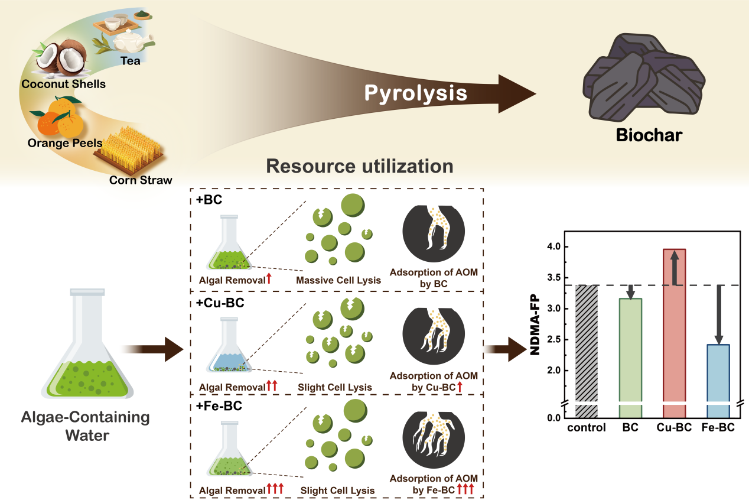
Figure 1 Graphical Abstract
Materials and Methods
This study selected Microcystis aeruginosa (FACHB-905) as the algal species for research due to its prevalence in natural water. The integrity of the algal cell membrane was evaluated by flow cytometry (NovoCyte 113 2060R). The concentration of NDMA in the algal cell solution, after 72 hours of contact with the biochar, was determined using a Gas chromatography-mass spectrometry (GC-MS) with the triple-quadrupole tandem mass spectrometer (TQ8050NX, Shimadzu, Japan).
Results and Discussion
Compared to CBC, better performance in both algae removal and NDMA-FP control was observed for biochars (BCs)(Figure 2). Copper (Cu) and iron (Fe) modifications were applied to NBC, TBC, and OBC. Cu-modified BC significantly improved algae removal (with a removal rate reaching 80%) but increased NDMA-FP. In contrast, Fe-modified BC not only exhibited improved algae removal but also demonstrated superior NDMA-FP control. Cu-modified BC caused the most severe physical damage to Microcystis aeruginosa with 85-99% membrane damage(Figure 3), likely due to reactive oxygen species produced by the algae. Fe-modified BC caused no significant physical damage, but it showed strong AOM adsorption. The control effects of the different BCs on algae-containing water were closely related to their physical damage to algae and their adsorption ability for AOM via calculation analysis. These findings provided valuable insights for enhancing algae removal processes and NDMA-FP control in drinking water treatment.
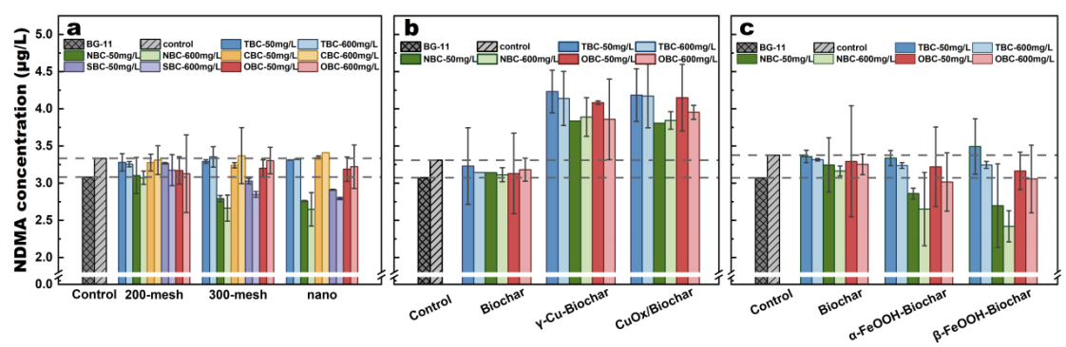
Figure 2 The effect of exposure to different types of BC on the NDMA-FP in algalcontaining water: a) different biomass materials and sizes of BC; b) Cu-BC; c) Fe-BC. The grid bar chart represents the NDMA-FP in the BG-11 algal medium, and the diagonal bar chart depicts the NDMA-FP in the control samples without BC.
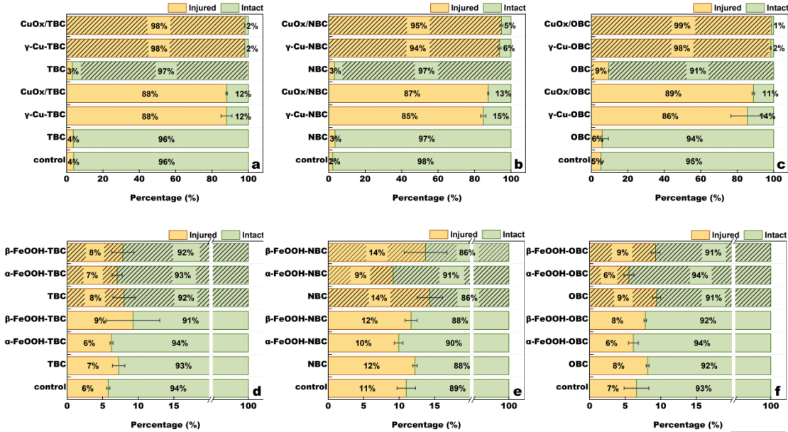
Figure 3 The influence of Cu-BC and Fe-BCon the integrity of algal cell membranes at the BC dosage of 600 mg/L (bar chart with diagonal lines) and 50mg/L(bar chart without diagonal lines).
Conclusions
- NDMA-FP control was better by biochar in algae water treatment than coal-based AC.
- Cu-modified BC showed more significant algae removal than Fe-modified BC.
- NDMA-FP increased significantly treated by Cu-modified BC due to membrane damage.
- NDMA-FP control by Fe-BC was due to weak membrane damage and strong AOM adsorption.
References
[1] Qin W., Yang J., Zhang C., Song Y.*, Jiang J., Ma J., 2025. The role of biochar in algal source water treatment: Algal cells integrity and NDMA formation potential. J. Hazard. Mater. 492: 138292.
[2] Zhou S., et al. 2015. Characteristics of C-, N-DBPs formation from algal organic matter: Role of molecular weight fractions and impacts of pre-ozonation, Water Res., 72: 381-390.
[3] Krasner S W, et al. 2013. Formation, precursors, control, and occurrence of nitrosamines in drinking water: A review. Water Res., 47(13): 4433-4450.
[4] Bei E, et al. 2016. Occurrence of nitrosamines and their precursors in drinking water systems around mainland China. Water Res., 98: 168-175.

